SATISH CHANDRA MEMORIAL SCHOOL
CASE-STUDY TEST (2024-25)
X
MATHEMATICS (041)
Time allowed: 30 min Maximum Marks: 7 X 2 = 14
CASE –STUDY I
1) Hardik repays his loan of Rs 1,32,000 by paying every month. Starting with the first installment of Rs 1500. He increases his installment by Rs 200 every month. . (1+1+1+2+2=7)


Based on the above information answer the following questions:

- If the amount paid in successive installments from an AP then write the first term and common difference.
A) Rs 132000, Rs 200 | B) Rs 200, Rs 1500
C) Rs 1500, Rs 200 | D) None of these

- What is the amount paid by Hardik in 15th installment?
A) Rs 4200 | B) Rs 4300
C) Rs 4400 | D) None of these

- In which installment will he pay Rs 5500?
A) 19 | B) 20
C) 21 | D) None of these

- What is the value of k if 11, 2k+1, 3k-1 form an AP?
A) –12 | B) –13
C) 8 | D) None of these

- How many instalments shall clear debt?
A) 26 | B) 28
C) 30 | D) None of these

CASE –STUDY II

- Basketball and soccer are played with a spherical ball. Even though an athlete dribbles the ball in both sports, a basketball player uses his hands and a soccer player uses his feet. Usually, soccer is played outdoors on a large field and basketball is played indoor on a court made out of wood. The projectile (path traced) of soccer ball and basketball are given in the figure below of representing a polynomial. (1+1+1+2+2=7)



Based on the above information answer the following questions:
- The shape of the path traced shown is
- Spiral | - Ellipse
c) Linear | d) Parabola

- The graph of parabola opens upwards, if _______
- a = 0 | - a < 0
c) a > 0 | d) a ≥ 0

- Observe the following graph and answer

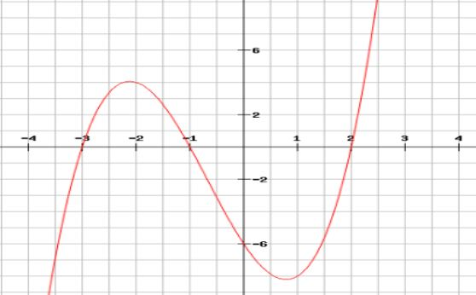

In the above graph, how many zeroes are there for the polynomial?
- 0 | - 1
c) 2 | d) 3

- The zeroes in the above shown graph are
- 2, 3,-1 | - -2, 3, 1
c) -3, -1, 2 | d) -2, -3, -1

- If the sum of the roots is p and product of the roots is -p, then the quadratic polynomial is:
- k(px² + px + p) | - k(px² - x/p-1)
c) k(x² - px - p) | d) k(x² - px + p)

